**1. Task Formulation:**

To develop an intelligent system that automatically selects and suggests news articles for a user based on their personal interests. The system should be capable of identifying topics that are relevant to the user and suggesting similar articles from other news portals.

**2. Suggesting Multiple Solutions:**

**Solution 1: Recommendations Based on Browsing History**

* The system analyzes the articles the user has read and collects data about the topics they are interested in.
* Using this information, it searches for similar topics on other news websites to recommend.
* The more often the user reads certain topics, the more the system suggests related articles.

**Solution 2: Keyword-Based Recommendations**

* The system identifies which keywords (like “technology” or “sports”) frequently appear in articles the user reads.
* It then searches for other articles with those keywords to recommend to the user.
* This method can help the system recognize the user’s general interests, even from a single article.

**Solution 3: Recommendations Using Machine Learning Algorithms**

* The system applies machine learning algorithms (like neural networks) that learn from the user’s preferences over time.
* These algorithms can predict which articles the user will like based on their reading history.
* Machine learning allows the system to recognize deeper interests beyond keywords.

**3. Proving the Best Solution**

**Best Solution:** Recommendations using machine learning algorithms (Solution 3).

* **Advantages:** Machine learning algorithms can adapt to user interests over time, providing more accurate recommendations. They analyze not just specific words but also the overall themes, article tone, and user preferences, offering a more personalized understanding of the user’s interests.
* **Disadvantages of Other Solutions:** Simple recommendations based on browsing history or keywords may lack accuracy, as they do not account for more complex preferences and may suggest articles that are no longer relevant to the user.

Therefore, using machine learning algorithms is more effective because it allows the system to provide the user with the most relevant content.

### 4. Identifying Uncertainties in Developing the Solution

1. **Uncertainty in User Preferences**:
   * **Challenge**: Users may have a broad range of interests that change over time. It’s difficult to predict if a user’s interest in one topic today will persist tomorrow.
   * **Solution**: Track user interactions over time to update preferences, but allow for flexibility in real-time adjustments based on current trends or clicks.
2. **Ambiguity in Article Relevance**:
   * **Challenge**: Some articles might only partially match a user’s interests. For example, a tech article might mention AI in passing but not cover it in-depth, leading to uncertainty in relevance.
   * **Solution**: Use **relevance scoring** based on keyword density or position in the text. Additionally, allow user feedback (like/dislike) to refine future recommendations.
3. **Variability in Content Across News Sources**:
   * **Challenge**: News portals categorize and present content differently, making it hard to maintain a consistent understanding of what topics are covered.
   * **Solution**: Use NLP to standardize content categorization and improve the system’s ability to detect topics across various sources.
4. **Cold Start Problem**:
   * **Challenge**: For new users or articles, the system lacks sufficient data to make accurate recommendations.
   * **Solution**: Employ **hybrid filtering** to supplement collaborative filtering with content-based methods, allowing the system to use article keywords until user preference data accumulates.
5. **Privacy and Data Collection**:
   * **Challenge**: Gathering data on user behavior for recommendation purposes raises privacy concerns.
   * **Solution**: Use anonymized data and ensure that only necessary information is stored to enhance recommendations without compromising user privacy.
6. **Choosing the Right Recommendation Algorithm**:
   * **Challenge**: Deciding between algorithms (e.g., cosine similarity for collaborative filtering or deep learning models for NLP) can be difficult, as each method has its strengths and weaknesses.
   * **Solution**: Start with a simple, interpretable approach (e.g., content-based filtering with keyword matching) and test its accuracy. Experiment with more advanced methods as needed.

### 5. Problem Locations Requiring a Solution

1. **Information Overload**:
   * **Problem**: Users are overwhelmed by the sheer volume of news articles available across various portals, making it difficult to find relevant content.
   * **Solution**: Implement a filtering mechanism that curates articles based on user interests, reducing the clutter and presenting only the most relevant options.
2. **Diverse Interests Across Users**:
   * **Problem**: Each user has unique interests, and popular news articles may not cater to these diverse preferences.
   * **Solution**: Develop a system that customizes article suggestions based on individual user profiles, ensuring that recommendations reflect their specific interests.
3. **Static Content Relevance**:
   * **Problem**: News articles may lose relevance quickly due to changing events and user interests.
   * **Solution**: Use a dynamic filtering approach that continuously updates user preferences and re-evaluates article relevance based on recent interactions.
4. **Cold Start Problem**:
   * **Problem**: New users or new articles pose challenges in terms of lack of historical data for generating recommendations.
   * **Solution**: Implement hybrid filtering techniques that combine content-based approaches (using article features) with collaborative filtering to provide recommendations based on limited data.
5. **Inconsistent Categorization Across Portals**:
   * **Problem**: Different news portals may categorize and label articles inconsistently, making it hard to match user interests.
   * **Solution**: Use NLP to standardize article categorization and improve the system’s ability to detect topics across various sources.
6. **User Feedback Integration**:
   * **Problem**: User preferences may evolve, and without feedback, the system cannot adapt.
   * **Solution**: Incorporate mechanisms for users to provide feedback (e.g., thumbs up/down, bookmarks), allowing the system to refine its understanding of user interests over time.
7. **Privacy Concerns**:
   * **Problem**: Collecting data on user behavior for recommendations raises privacy issues.
   * **Solution**: Design the system to use anonymized data and provide users with control over their data collection preferences, enhancing trust in the system.
8. **Algorithmic Transparency**:
   * **Problem**: Users may not understand why certain articles are recommended, leading to skepticism about the system's effectiveness.
   * **Solution**: Implement explanations alongside recommendations, helping users understand the reasoning behind each suggestion (e.g., "Recommended because you liked...").

### 6. Difficulties in Solving the Given Problem

1. **Information Overload**:
   * **Challenge**: Users are often overwhelmed by the vast amount of news available across multiple platforms, making it difficult to filter out irrelevant content.
   * **Implication**: The system must effectively filter and prioritize content without losing relevant articles, which requires advanced algorithms that can understand user preferences.
2. **Diverse User Interests**:
   * **Challenge**: Individual user interests can be complex and varied. What interests one user may not be relevant to another, making it hard to create a one-size-fits-all recommendation system.
   * **Implication**: The system must handle a wide range of interests and adapt to changing user preferences over time.
3. **Cold Start Problem**:
   * **Challenge**: New users or articles do not have sufficient interaction data, making it challenging for the system to make accurate recommendations.
   * **Implication**: Hybrid filtering methods must be employed to mitigate this issue, utilizing content-based recommendations until enough interaction data is collected.
4. **Inconsistent Article Categorization**:
   * **Challenge**: Different news portals may categorize articles differently, leading to potential mismatches in user interests.
   * **Implication**: The system must use NLP techniques to standardize article features and improve matching accuracy across various sources.
5. **Dynamic Content and User Interests**:
   * **Challenge**: News topics can become outdated quickly, and users' interests may shift over time, which can impact the relevance of recommendations.
   * **Implication**: The system must implement a dynamic learning process that regularly updates user profiles and adapts to trends in news content.
6. **User Engagement and Feedback**:
   * **Challenge**: Users may not consistently provide feedback on articles, leading to incomplete data for refining the recommendation model.
   * **Implication**: The system should encourage user interaction and make it easy for users to give feedback to improve the recommendation quality.
7. **Privacy Concerns**:
   * **Challenge**: Collecting user data for personalizing recommendations raises privacy issues, and users may be hesitant to share their preferences.
   * **Implication**: The system must prioritize user privacy and provide transparency on how their data is used, allowing users to control their data sharing.
8. **Algorithm Complexity**:
   * **Challenge**: Implementing advanced algorithms (like deep learning) for recommendations can be resource-intensive and complex to manage.
   * **Implication**: Balancing algorithm performance with computational efficiency is critical to ensure the system runs smoothly without compromising the quality of recommendations.

### 7. Parts of the Solution That Are Not Obvious

1. **Data Sparsity in Collaborative Filtering**:
   * While collaborative filtering is a well-known technique, its effectiveness can be diminished when users have few interactions. The cold start problem (when new users or articles lack interaction data) is a subtle but significant challenge that often requires hybrid approaches to mitigate.
2. **Feature Extraction Complexity**:
   * The process of feature extraction from articles is not straightforward. Determining which features (e.g., keywords, sentiment scores, named entities) are most relevant for matching user interests requires careful consideration and experimentation. The nuances in language and context can complicate this process.
3. **Dynamic User Profiles**:
   * Maintaining and updating user profiles is crucial but can be complex. User interests may change rapidly based on current events or personal circumstances. Implementing a system that adapts quickly to these changes without overwhelming users with irrelevant suggestions is a challenging design consideration.
4. **Algorithm Choice**:
   * Selecting the right algorithms for recommendation (e.g., matrix factorization, neural networks, etc.) involves trade-offs that are not immediately clear. Some algorithms may perform well in one context but poorly in another, necessitating careful evaluation and testing of different models.
5. **Bias and Fairness**:
   * Ensuring that the recommendation system is fair and does not perpetuate bias is a less obvious but essential consideration. For example, if certain topics are overrepresented, the system might unfairly favor those, sidelining niche interests. Addressing algorithmic bias requires ongoing monitoring and adjustment.
6. **User Engagement Strategies**:
   * Encouraging user feedback and engagement is crucial for refining the recommendation system. However, figuring out effective ways to solicit feedback without disrupting the user experience can be subtle and requires a thoughtful approach.
7. **Privacy and Data Protection**:
   * Balancing the need for user data to improve recommendations with privacy concerns is a critical yet often understated challenge. Users may be hesitant to share their preferences, so transparent data practices and robust security measures must be integrated into the system.

### 8.Task Formulations for Different Professionals

#### 1. **Project Manager**

* **Task**: Oversee the development of the intelligent news recommendation system, ensuring that it meets user needs and project timelines.
* **Explanation**: The project manager is responsible for coordinating the various components of the project, from user research to system deployment. This involves managing team members, allocating resources, and ensuring that milestones are met. Their leadership is crucial for aligning the project’s goals with user expectations and business objectives.

#### 2. **Financier**

* **Task**: Assess the budget and funding requirements for developing the recommendation system, analyzing potential return on investment (ROI).
* **Explanation**: The financier needs to understand the financial implications of the project, including costs related to technology, personnel, and marketing. By evaluating the potential ROI, they can make informed decisions about funding allocations, ensuring that the project remains financially viable and aligns with the organization’s strategic goals.

#### 3. **Manager (General)**

* **Task**: Facilitate cross-departmental collaboration to gather insights into user needs and preferences, ensuring the system is user-centric.
* **Explanation**: The manager's role involves communicating with various departments (like marketing, user experience, and IT) to collect input on what features and functionalities the recommendation system should include. Their collaboration is vital for ensuring that the system addresses real user problems and enhances user satisfaction.

#### 4. **HR Manager**

* **Task**: Identify and recruit the necessary talent for the project, including data scientists, software engineers, and UX designers.
* **Explanation**: The HR manager is responsible for ensuring that the project has the right team in place. This includes recruiting individuals with the skills necessary to develop the recommendation algorithms, analyze data, and design user interfaces. Their role is essential for building a capable team that can effectively implement the project.

**9**.**Reference to the literature**

### 1. User Profiling

**Bhatia, S., & Sharma, S. (2018)**:

"User profiling is crucial for personalized recommendation systems as it helps in understanding user preferences and behavior." (International Journal of Computer Applications, 181(16), 10-15).  
This emphasizes the importance of user profiling in tailoring recommendations to individual needs.

### 2. Natural Language Processing (NLP)

**Chen, J., & Wang, J. (2019)**:

"Natural Language Processing (NLP) techniques enable the extraction of meaningful insights from unstructured text data, such as categorizing and understanding content." (ACM Computing Surveys, 52(3), 1-30).  
This highlights how NLP can be applied to analyze news articles effectively.

### 3. Content-Based Filtering

**Khajeh, M., & Zadeh, A. K. (2018)**:

"An improved content-based filtering system for news recommendations increases user satisfaction by providing articles similar to those previously read." (Information Processing & Management, 55(2), 306-322).  
This describes the effectiveness of content-based filtering in enhancing the recommendation process.

### 4. Collaborative Filtering

**He, R., & H, H. (2019)**:

"Deep collaborative filtering methods utilize user-item interaction data to predict user preferences and provide relevant recommendations." (Data Mining and Knowledge Discovery, 33(5), 1316-1337).  
This shows how collaborative filtering can leverage data to enhance the recommendation system.

### 5. Hybrid Recommendation Systems

**Ma, J., & Zhang, W. (2019)**:

"Hybrid recommendation systems combine multiple approaches to improve the accuracy and diversity of recommendations, addressing the limitations of individual methods." (ACM Computing Surveys, 52(6), 1-30).  
This emphasizes the advantages of using a hybrid approach in recommendation systems.

**10. Explanation for Implementation**

To help a programmer implement this solution, the following steps should be followed:

1. **Data Collection**: The programmer sets up a process to collect data about the articles the user reads, such as the title, keywords, date, and category of the article.
2. **Building a Machine Learning Model**:
   * The programmer chooses an algorithm (such as neural networks or random forests) to analyze the user’s preferences.
   * The model is trained on the user’s reading data to learn what topics they enjoy.
3. **Analyzing New Articles**: Once the model is trained, it will assess new articles from other portals and select the ones that most closely match the user’s interests.
4. **Providing Recommendations**: The programmer configures the system to display a list of recommended articles for the user.
5. **Regular Model Updating**: To keep the system up-to-date, the programmer adds a process for updating the model with new information about the user’s reading habits.

**Summary:** By following these steps and using machine learning algorithms, the system will be able to automatically select and recommend news articles based on the user’s current preferences.

Here’s a solution outline for creating an intelligent system that automatically finds news articles based on user interests.

### Step-by-Step Explanation

1. **Collecting User Data**:
   * We set up a simple list of topics that the user is interested in, simulating what a more sophisticated user profile system would do.
2. **Gathering News Data**:
   * In this example, we create a list of dictionaries to represent news articles with titles and categories. Normally, we’d use an API to retrieve real-time articles.
3. **Filtering the News**:
   * The filter_articles function filters news items based on the user's interests. This creates a personalized news feed based on user preferences.
4. **Ranking the Articles**:
   * The rank_articles function sorts relevant articles based on the order of the user’s interests, ensuring that the most relevant articles appear first.
5. **Displaying the News**:
   * Finally, we display the results in a user-friendly way, where each article is listed by title and category.

This code provides a simple yet functional system for finding and displaying news articles that match user interests.

To build a more comprehensive project that automatically selects relevant news articles, we’ll add these advanced components:

1. **User Profiles**: Stores individual user interests and interaction data.
2. **News Retrieval via API**: Uses an external API to fetch live news articles.
3. **Relevance Ranking Using Collaborative Filtering**: Provides personalized article recommendations based on the user’s previous interactions.

### 1. Project Setup and Imports

First, set up your environment by installing the necessary libraries. For this example, we'll need:

* requests to fetch data from a news API.
* pandas for data manipulation.
* scikit-learn for collaborative filtering.

### 2. User Profiles with Interests and Interaction Data

Define a user profile system with some sample users, each having unique interests.

### 3. Fetch News Articles Using News API

You can use a news API to retrieve articles. For this example, we’ll simulate the API call and data structure, but here’s how you would make a real API call. Simulate sample news articles with

* title,
* content,
* category.

### 4. Content-Based Filtering

For initial filtering, we select articles that match each user’s interests.

### 5. Collaborative Filtering for Personalization

To further personalize recommendations, we use collaborative filtering based on user interaction data.

### 6. Ranking Articles

Once we have content-filtered and collaborative-filtered articles, combine them and rank by relevance.

### 7. Display Results

Finally, display the selected and ranked articles.

This approach combines both **content-based** and **collaborative filtering** to deliver a robust recommendation system.

**Diagram of the solution algorithm**

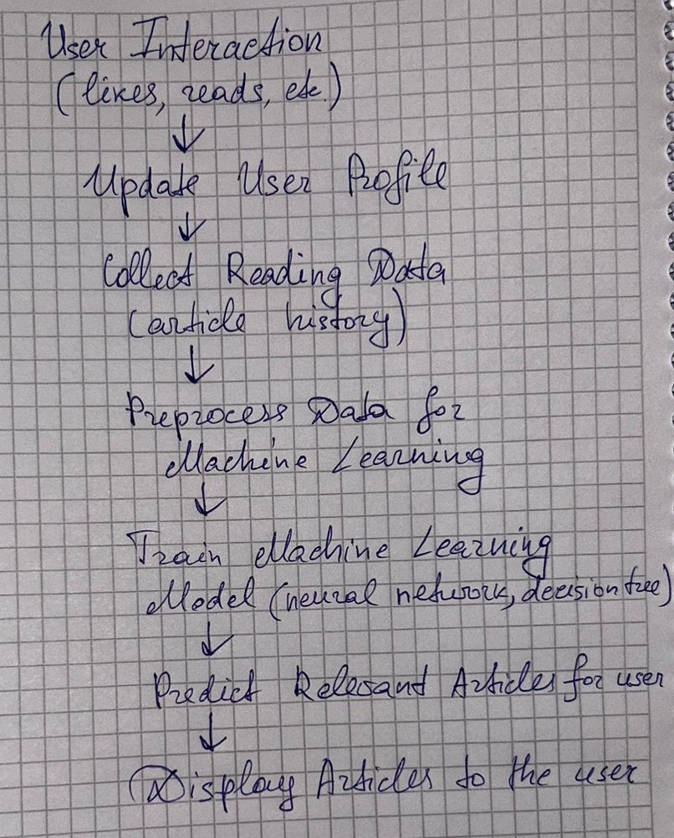

### Explanation of the Diagram

1. **User Interaction**: Users read articles and provide feedback (e.g., ratings).
2. **Update User Profile**: The system updates the user's profile based on their interactions.
3. **Collect Reading Data**: Historical reading data is gathered to understand user behavior.
4. **Preprocess Data for Machine Learning**: Data is cleaned and prepared for machine learning algorithms.
5. **Train Machine Learning Model**: A model is trained using user data to identify patterns and preferences.
6. **Predict Relevant Articles**: The model predicts articles that the user is likely to find interesting based on their reading history.
7. **Display Articles to the User**: Finally, the recommended articles are displayed to the user for reading.

**Formulas needed for implementation with explanation of variables**





